INTRODUCTION TO KUBERNETES AND ORCHESTRATION

What is Kubernetes
- Kubernetes is a free and open-source system for autoscaling, autohealing, deployment & load balancing.
- It’s a tool for managing the containers
- It is also known as orchestration tool
- Orchestration ---> container management tool
Orchestration simply means clustering any number of containers which are running on different network
- Docker swarm ---> specific to managed docker containers
- Kubernetes ------> managed any container
History
- google developed an internal system called borg (later named as omega) to deploy and manage thousands of google applications and services on their cluster.
- In 2014 google introduced Kubernetes an open-source platform written in golang and later donated to CNCF (cloud native computing foundation)

Online Platform for K8s
- Kubernetes playground (killerkoda)
- play with k8s
- play with Kubernetes classroom
Cloud Based K8s Services
- GKE (google Kubernetes services)
- AKS (azure Kubernetes services)
- EKS (elastic Kubernetes services)
Kubernetes Installation Tools
- Minikube
- kubeadm
- kind

Problems With Scaling Up the Containers
- containers cannot communicate with each other
- Autoscaling and load balancing was not possible
- containers had to be managed carefully

Feature of Kubernetes
- Orchestration
- Autoscaling (vertical / horizontal)
- Auto-healing
- load balancing
- platform independent
- fault tolerance
- Rollback
- Health monitoring of containers
- Batch execution

Difference between the kubernetes & Docker swarm
Feature | Kubernetes | Docker Swarm
Difficulty | Harder to learn | Easy to learn
Setup | Complex | Simple
Scaling | Very powerful | Basic scaling
Networking | Advanced | Simple
Auto-healing | Strong | Limited
Load Balancing | Advanced | Basic
Best For | Large production apps | Small/simple projects
Community Support | Huge | Smaller
Cloud Support | Supported everywhere | Limited support
Speed | Slightly slower setup | Faster setup

KUBERNETES ARCHITECTURE
Cluster ----> Node -----> Pod -----> container ----> microservice (application)
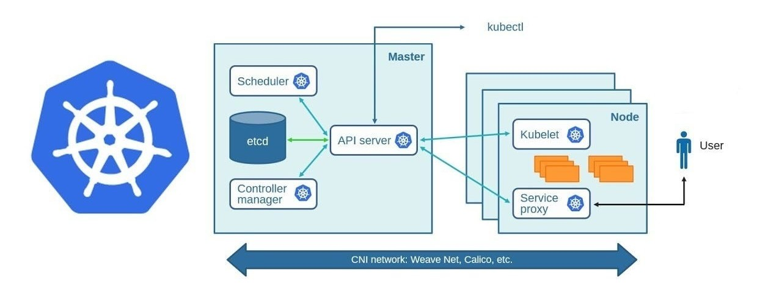
CONTROL-PLANE COMPONENTS (MASTER-NODE)
1.API Server
- API Server is the main entry point of Kubernetes Control Plane.
Users, kubectl, and other components communicate through it.
- When we apply a YAML/JSON file using kubectl apply, the request first goes to the API Server.
- API Server validates the request and stores cluster information in the ETCD database.
- It acts like the front-end and communication hub between all Kubernetes components.

2.ETCD Server
- ETCD works as the database of Kubernetes cluster.
- It stores all cluster information in key-value format, such as Pods, Nodes, ConfigMaps, Secrets, and cluster status.
- API Server reads and writes all data to ETCD, making it the source of truth for the cluster.
- ETCD is highly available, secure, and fully replicated so cluster data remains safe and consistent.

3.Kube Scheduler
- Scheduler watches for newly created Pods that do not have any node assigned.
- After detecting a new Pod, it checks available Worker Nodes.
- It selects the best suitable node based on CPU, memory, resources, and policies.
- Once selected, Scheduler informs the API Server about the assigned node for that Pod.
4.Controller Manager
- Controller Manager continuously checks whether the actual state matches the desired state.
- If something goes wrong (Pod crash, Node failure), it automatically tries to fix it.
- It contains multiple controllers like:
  - Node Controller
  - Replication Controller
  - Endpoint Controller
- In cloud environments it uses Cloud Controller Manager, and in non-cloud environments it uses Kube Controller Manager.

WORKER-NODE COMPONENTS
1. Kubelet
  - Kubelet is an agent running on every Worker Node in Kubernetes.
  - It continuously listens to the API Server for Pod creation and management instructions.
  - Kubelet creates and manages Pods and containers on the Worker Node.
  - It sends the Pod status and health reports (success/failure) back to the Master Node.
2. Kube Proxy
- Kube Proxy is responsible for network communication inside the cluster.
- It helps Pods communicate with other Pods and Services using networking rules.
- It runs on every Worker Node and manages traffic forwarding.
- It maintains network rules so each Pod can be accessed properly using its IP address.

3. Container Engine
- Container Engine is responsible for creating and running containers inside Pods.
- It works together with Kubelet to manage container operations.
- It pulls container images from registries like Docker Hub.
- It starts, stops, and exposes containers on the ports defined in the manifest file.
4. Pods
- Pod is the smallest deployment unit in Kubernetes.
- A Pod can contain one or more tightly coupled containers running together.
- Kubernetes manages Pods, not individual containers directly.
- Usually, one Pod contains one container for better fault isolation and management.

Multi-Container Pods
- Multiple containers inside the same Pod can share the same network and memory space.
- Containers inside a Pod can communicate with each other using localhost.
- All containers in the Pod can share the same storage volume/data.
- Containers inside a Pod are deployed and managed in an all-or-nothing manner (if Pod fails, all containers are affected).
- Entire Pod runs on the same Worker Node, and the Scheduler decides on which node the Pod will run.

WORKING FLOW OF Kubectl COMMAND
- kubectl is a command-line tool used by users/admins to interact with the Kubernetes cluster.
- When we run commands like:
kubectl apply -f pod.yaml ------> the request first goes to the API Server.
- kubectl does not directly create Pods or containers.
It only sends instructions/requests to the Control Plane through the API Server.
- API Server processes the request and coordinates with:
- ETCD → stores cluster data
- Scheduler → selects node
- Controller Manager → maintains desired state
- Kubelet → creates Pod on Worker Node
WORKING FLOW OF KUBERNETES
- User applies YAML file using kubectl apply -f pod.yaml.
- Request goes to the API Server.
- API Server validates the request and stores cluster data in ETCD.
- Scheduler detects a new Pod without a node assignment.
- Scheduler selects the best Worker Node and updates the API Server.
- Controller Manager ensures the desired Pod is running properly.
- Kubelet on Worker Node receives instructions from API Server.
- Container Runtime (Docker/containerd) creates and runs the container.
- Pod becomes Running and status is updated back into ETCD through API Server.

PODS LIFECYCLE
1. Pending
- Pod is created but not yet running.
- Scheduler is finding the best Worker Node.
- Images may still be downloading.
- Pod is waiting for required resources.
2. Running
- Pod is successfully assigned to a Node.
- Containers inside the Pod are created and started.
- Application is now running properly.
- Kubelet continuously monitors the Pod.
3. Succeeded
- All containers completed their work successfully.
- Pod stopped without any error.
- Mostly used in batch jobs or one-time tasks.
- Pod will not restart again automatically.
4. Failed
- One or more containers stopped with an error.
- Application inside Pod crashed or failed.
- Kubernetes may create a new Pod depending on restart policy.
- Failed Pod status is stored in ETCD.
5. Unknown
- Kubernetes cannot determine Pod status.
- Usually happens due to Node or network issues.
- API Server cannot communicate with Kubelet.
- Pod state becomes temporarily unknown.

